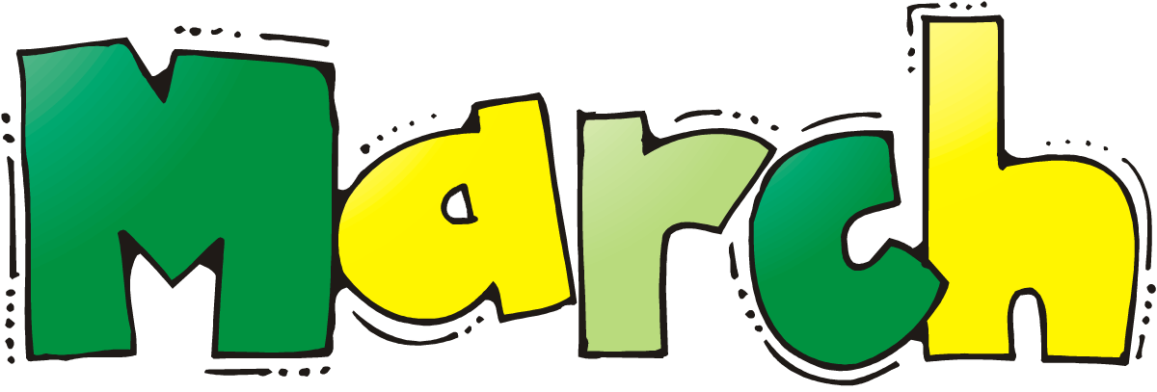
Mon | Tue | Wed | Thu | Fri
26  Bkfst-Milk, cereal, apples  Lunch- Chicken nuggets, kidney beans, fruit cocktail, bread  Pm Snack-Apple juice, pretzels | 27  Bkfst-Milk, Oatmeal, crushed pineapple  Lunch-rotisserie chicken, ranch style beans, peaches, bread  Pm Snack- Orange juice, gold fish cracker | 28  Bkfst-Milk cereal, fruit cocktail  Lunch-Milk, ground beef, cheddar cheese, corn tortilla, pine apple green beans  Pm Snack-Apple juice, yogurt | 1  Bkfst-Milk, biscuits, bananas  Lunch-ground beef, beef stroganoff, apple sauce, mix vegetables, bread  Pm Snack-Orange juice, trail mix | 2  Bkfst-Milk, cereal, crushed pine apple  Lunch-Milk, bologna & cheese sandwich, tomatoes, raisins, bread  Pm Snack- Grape juice, yogurt
5  Bkfst-Milk, oat meal, pears  Lunch-Milk, beef franks, pinto beans, apple sauce, bread  Pm Snack-Orange juice, trail mix | 6  Bkfst-Milk, cereal, crushed pine apple  Lunch-Milk, rotisserie chicken, tomatoes, apples, corn tortillas  Pm Snack-Apple juice, yogurt | 7  Bkfst-Milk, cereal, sliced peaches  Lunch-Milk, chicken nuggets, green beans, sliced pears, bread  Pm Snack- crackers with cheese, water | 8  Bkfst-Milk, cereal, bananas  Lunch-Milk, beef franks, hot dog buns, mixed vegetables, peaches  Pm Snack-Grape juice, yogurt | 9  Bkfst-Milk, cereal, bananas  Lunch-Milk, grilled cheese sandwich, raisins, corn, bread  Pm Snack-Apple juice, pretzels
12  Bkfst-Milk, cereal, peaches, bread  Lunch-Milk, chicken nuggets, green beans, pears, bread  Pm Snack-Orange juice, pretzels | 13  Bkfst-Milk, pears, oatmeal  Lunch-Beef franks, pinto beans, fruit cocktail, corn, tortillas  Pm Snack-Apple juice, trail mix | 14  Bkfst-Milk, cereal, fruit cocktail, bread  Lunch-Milk, rotisserie chicken, peaches, corn, bread  Pm Snack-Orange juice, cheese & crackers | 15  Bkfst-Milk, oatmeal, apple sauce  Lunch-Milk, beef frank, green beans, peaches, hot dog buns  Pm Snack-Grape juice, gold fish crackers | 16  Bkfst-Milk, cereal, bananas  Lunch-Bologna & cheese sandwich, tomatoes, crushed pine apple, bread  Pm Snack-Orange juice, yogurt
19  Bkfst-Milk, oranges, cereal  Lunch-Milk, ground beef, gravy, Mashed potatoes, apple sauce, green beans, bread  Pm Snack-Apple Juice, Snack mix | 20  Bkfst-Milk, pears Oatmeal  Lunch-Milk, ground beef, Stroganoff, corn, crushed pine apple, corn tortillas  Pm Snack-Orange juice, yogurt | 21  Bkfst-Milk, peaches, egg, bread  Lunch-Milk, ground beef, spaghetti sauce, dry spaghetti, green beans, raisins, crackers  Pm Snack-Grape juice, Granola dry | 22  Bkfst-Milk, cereal, apple sauce  Lunch-Milk, ground beef, sloppy joe mix, corn, diced tomatoes, apples, bread  Pm Snack-Apple juice, pretzels | 23  Bkfst-Milk, cereal, bananas  Lunch-Milk, ham & cheese sandwich, tomatoes with ranch, fruit cocktail, bread  Pm Snack-Orange juice, yogurt
26  Bkfst-Milk, cereal, apples  Lunch- Chicken nuggets, kidney beans, fruit cocktail, bread  Pm Snack-Apple juice, pretzels | 27  Bkfst-Milk, Oatmeal, crushed pineapple  Lunch-rotisserie chicken, ranch style beans, peaches, bread  Pm Snack- Orange juice, gold fish cracker | 28  Bkfst-Milk cereal, fruit cocktail  Lunch-Milk, ground beef, cheddar cheese, corn tortilla, pine apple green beans  Pm Snack-Apple juice, yogurt | 29  Bkfst-Milk, biscuits, bananas  Lunch-ground beef, beef stroganoff, apple sauce, mix vegetables, bread  Pm Snack-Orange juice, trail mix | 30  Bkfst-Milk, cereal, crushed pine apple  Lunch-Milk, bologna & cheese sandwich, tomatoes, raisins, bread  Pm Snack- Grape juice, yogurt

